**Unit 6**

**Write an essay of about 120 words. Choose a question below:**

-Should people have animals as pets? 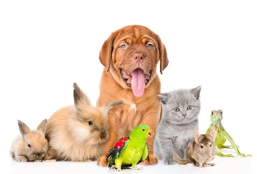

-Should we all become vegetarians? 

-Should we stop using plastic bags? 

You can read page 103 to help you

Cordero Evangelina

Should people have animals as pets

Everyday more and more people have animals as pets, although some people have them as their children. So, should we all have pets?

Many people think that it is important to have a pet for your children because they improve physical and emotional interaction. Also, having a pet helps to rescue abandoned animals. A house with pets is happier because they play and interact with all the family, they encourage the feeling of accompaniment and responsibility. Some people have a pet as their kids. For example, they sleep together, they take them to a holiday, and they don’t go to places that aren’t pet friendly. it is a problem when their animals die, because the people fall into depression.

However, there are people who don’t want to have pets for multiple reasons. Because they either live in apartments or small houses without a garden, they work many hours and don’t have time to take care of them, they can’t spend money on vets and pet´s food, they don’t want extra responsibility or suspend their activities to go out with their pet.

In conclusion, the new generation has developed a feeling of caring to animals. That is why they rescue abandoned animals, instead of paying for a purebred animal